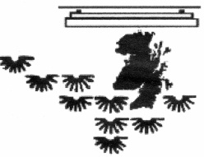
Scottish Bonsai Association Membership
Application / Renewal Form

New membership… Renew current membership… No.

Type of membership required. (Please tick)
Ordinary………………………….£17.50Request SBA enamel badge
Senior Citizen or UB40 Holder….£15.00£2
Junior (in full time education)…...£ 5.00
Family……………………………£25.00
Method of Payment.CashChequeS. Order

Please tick if you wish your newsletter delivered by, EmailPost

For Office Use Only.

Membership YearCard SentBadge Sent
Member’s names and addresses are kept on a secure computer file and never made available to third parties. Should you wish this NOT to be the case, please contact the membership secretary.
Please return this form with the appropriate fee to the SBA Membership Secretary:
Alan Couper, 25 Jubilee Road, DENNY, FK6 6NH.
Cheques should be made payable to “Scottish Bonsai Association”.
A standing order mandate is available on request.
Surname: _________________________Forename: ____________________
2nd Applicant name (if applicable): _____________________________________
Address: _________________________________________________________
__________________________________________________________________
Post Code: ___________________ Tel: ______________________
Email: ___________________________________________________________
Signature: ___________________________ Date: ______________
Membership Year: 1st October to 30th September. New members joining after 1st March will receive extended Membership to 30th September of the year following their application (i.e. up to 17 months Membership).

